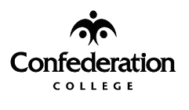

ADVANCED LOCAL

VEHICLE RESERVATION APPROVAL

COMPANY: | ENTERPRISE RENT-A-CAR
ATTENTION: | SARAH MINOR
FAX NUMBER: | (807) 467-2779
FROM:
Name:
Department
Phone Number |  | Fax Number
Date |  | Total # Pages

RENTED BY: | REQUESTED BY:
VEHICLE REQUESTED:

DATE & TIME OF DEPARTURE: | DATE OF RETURN:
DELIVER VEHICLE TO KENORA CAMPUS: YES NO
SPECIAL INSTRUCTIONS:

CHARGE TO BLANKET ORDER NO. BL016609: YES NO
(ONLY USED BY KENORA OFFICE)
SIGNATURE

ENTERPRISE PHONE NUMBER: (807) 467-2800
PLEASE CONFIRM RECEIPT OF THIS FAXED RESERVATION BY CALLING:

NAME: _________________________________ PHONE: ______________________

