AB XX | Students on Unpaid Placement Procedure (Covid-19)
Responsible Authority: | Organizational Effectiveness
Approval Authority: | Senior Team
Date First Approved: | NEW
Date Last Reviewed: | September 2020
Mandatory Review Date: | TBD

PURPOSE
To ensure Confederation College adheres to the Guidelines for Workplace Insurance for Postsecondary Students on Unpaid Work Placements as developed by the Ministry of Training, Colleges & Universities (MCU).

The Government of Ontario, through MCU, provides workplace insurance coverage for students who participate in unpaid work placements as part of an approved academic program. Student trainees are eligible to make a claim for insurance benefits should they suffer a work-related accident or illness while on an eligible placement. Coverage is provided by the MCU to encourage employers to participate in the unpaid student placement program that might be deterred by potential insurance implications or increases in WSIB premiums.

SCOPE
This procedure applies to all Confederation College departments that arrange unpaid student work placements that are eligible to receive WSIB benefits or private insurance coverage (Chubb), as set out under the “Guidelines for Workplace Insurance for Postsecondary Students on Unpaid Work Placements”.

DEFINITIONS
This includes an explanation of terms and abbreviations used within the policy and procedure.

Word/Term | Definition
Chubb | Chubb Insurers is a private insurance company retained by the Government of Ontario.
Approved Program | A postsecondary program offered by Confederation College that is funded through a MCU operating grant.
Health Care Injury | An injury that requires the professional skills of a health care practitioner and/or treatement in a hospital facility.
Lost Time Injury | An injury that results in a worker losing time from work following the day of the injury. Lost time injuries must be medically supported.
Placement Coordinator | An employee of Confederation College who arranges unpaid work placements for students and who provides support for students during placement.
Placement Employer | The employer with whom the student trainee is placed by Confederation College to receive training as part of the requirements of his/her approved program.
Placement Supervisor | The supervisor at the placement organization who directs the activities of the student trainee and/or who is in control of the local workplace during the student’s placement.
Student Trainee | A student participating in an unpaid work placement with a placement employer.
Training Agency | A postsecondary educational institution that is funded by a MCU operating grant. For this document, the training agency is Confederation College.
Unpaid Work Placement | An unpaid work placement that is required as part of an approved program offered by Confederation College.
Worker | A person who performs work or suppolies services for monetary compensation and also to students (secondary school, college or university) who perform work or supply services for no monetary compensation under a program-approved work experience placement as defined in the Occupational Health and Safety Act.
WSIA | Workpalce Safety and Insurance Act, 1997
WSIB | Workplace Safety and Insurance Board

PROCEDURE

 | Responsibilities
 | Deans, Chairs, Managers and Supervisors
 | 1.1.1 Ensure the employees supervising placements follow this procedure and the MCU guidelines for all students on unpaid work placements.
 | 1.1.2 Ensure academic areas provide Chubb data reports (where applicable) for their programs and submit a copy to Organizational Effectiveness at the end of each semester (January, May and September).
1.2 | Placement Coordinators
 | 1.2.1 Arrange safe and suitable work placements for student trainees.
 | 1.2.2 Ensure all requirements prior to commencement of an unpaid work placement are followed as outlined in this procedure.
 | 1.2.3 Ensure the student trainees have read and signed the “Student Declaration of Understanding” so they are aware of their eligibility to make a claim for benefits and that their personal information will be shared with MCU and the respective insurance agency (WSIB or Chubb) in the event they are injured or contract an illness while on an eligible placement (Appendix 1). These forms must be kept for all placements.
 | 1.2.4 Ensure Placement Employers complete the “Letter to Placement Employer” confirming they understand the insurance coverage available to student trainees on unpaid work placements and that they are aware of the reporting procedures in the event the student is injured or contracts an illness (Appendix 2). These forms must be kept for all placements.
 | 1.2.5 Liase with student trainees and placement employers to monitor the progress and respond to any health and safety related concerns.
 | 1.2.6 Ensure Organizational Effectiveness receives the required information and completed forms in the event that a student trainee is injured while on placement.
 | 1.2.7 Coordinate a student’s return ot work, in consultation with Organizational Effectiveness, following an injury or illness on an unpaid placement.
1.3 | Student Trainees
 | 1.3.1 Complete and provide the original signed copy of the “Student Declaration of Understanding” (Appendix 1) letter to the Confederation College Placement Coordinator.
 | 1.3.2 Report any safety concerns at the unpaid work placement to the Placement Supervisor and contact the Confederation College Placement Coordinator if the safety concern is not resolved.
 | 1.3.3 Immediately report any work related accident, injury or illness to the Placement Supervisor and to the Confederation College Placement Coordinator.
 | 1.3.4 Complete an Accident/Incident Report with the Placement Employer and contact the Confederation College Placement Coordinator to complete an Injury Occurrence Report if a work related injury or illness occurs.
1.4 | Placement Employers/Placement Supervisors
 | 1.4.1 Follow the procedures outlined in this program and the MCU Guidelines for Students on Unpaid Work Placements.
 | 1.4.2 Complete Confederation College’s “Letter to Placement Employer” (Appendix 2).
 | 1.4.3 Provide a safe working environment and ensure student trainees are supervised and provided with safety orientation, information and equipment relevant to the workplace hazards.
 | 1.4.4 Follow the responsibilities and reporting procedures outlined in this document in the event of a workplace accident, injury or illness during the unpaid placement.
1.5 | Organizational Effectiveness
 | 1.5.1 Administer the accident claim (WSIB or Chubb) in the event of a student injury/illness/disease during an unpaid work placement.
 | 1.5.2 Liase with the Placement Coordinator, Student Trainee, WSIB, Chubb and/or the MCU on matters related to an injury/disease claim. The WSIB or Chubb may also contact the student trainee directly regarding their claim.
 | 1.5.3 Provide assistance and guidance regarding this procedure and the MCU guidelines.
 | 1.5.4 Compile and submit Chubb data reports to the MCU.
 | 1.5.5 Review and update this procedure when required.
 | MCU Workplace Insurance Coverage (WSIB and Chubb)
 | Coverage Eligibility

Student trainees must meet the following requirements to be eligible for MCU coverage (WSIB and Chubb):
- The placement must be authorized by Confederation College,
- The student must be enrolled in a MCU funded Confederation College program that requires an unpaid placement as part of their program,
- The student must participate, however minimally, in the activities of the placement employer’s industry,
- The placement employer does not pay the student,
- When the placement is arragned with an Ontario-based placement employer, the placement does not take place outside of Ontario,
- The placement must not be with Confederation College. If Confederation students are placed with Confederation College, WSIB coverage is provided by Confederation and not through the MCU program.
2.2 | Coverage Ineligibility

The following student are not eligible for MCU coverage (WSIB and Chubb):
- Students in postsecondary education or training programs that are not funded through MCU operating grants.
- Student trainees on unpaid work placements which are not a requirement for their program and which they have arranged or organized themselves. Such placements are considered volunteer work for the purposes of MCU coverage.
- Student trainees who receive payment must be provided with WSIB insurance coverage paid by the placement employer.
- Confederation College students on unpaid work placement with Confederation College. WSIB coverage is provided by Confederation College and not through MCU.
- Student trainees who are in the classroom portion of their training.
- Student trainees undertaking an unpaid placement at Confederation College, but whose training agency is outside Ontario.
- Student trainees who, as part of a formal course or program attend a placement with an Ontario placement employer but the placement occurs outside of Ontario.
2.3 | Out-of-Province or Out-of-Country Placements
 | 2.3.1 Student trainees on unpaid work placements outside of Ontario are covered under the private insurance (Chubb) plan. However, students should be advised to obtain additional insurance coverage since Chubb does not provide full compenstation or coverage during non-work placement hours. Chubb does not cover emergency health care except if health care is needed because of an accident while participating in the placement.
 | 2.3.1 Students opting for out-of-country placements should obtain their own travel insurance and extended health care coverage.
2.4 | Establishing the Type of Insurance Coverage (WSIB or Chubb)
 | 2.4.1 Accident insurance coverage will be provided by the WSIB for student trainees during unpaid work placement with employers that are covered by WSIB.
 | 2.4.2 Accident insurance coverage will be provided by Chubb Insurance for student trainees during unpaid work placements where the placement employer is not covered by WSIB. Examples of employers who are not required to carry insurance with the WSIB include but are not limited to: non-profit organizations, offices of lawyers, dentists, medical doctors and veterinarians.
 | Action |  | Responsibility
 | Prior to Commencement of Unpaid Work Placments
 | Student Notification |  | Placement Coordinator
 | Advise student trainees to become familiarized with the hazards at the placement employer’s site.
 | Advise student trainees of their responsibility to inform their placement site Supervisor immediately if they have any safety concerns or are injured or contract a work-related illness while on placement.

Ensure student trainees have read and signed the “Student Declaration of Understanding” (Appendix 1).
J:\COMMON\HR\STUDENTS ON UNPAID PLACEMENT FORMS
 | Retain a signed copy of the “Student Declaration of Understanding” and provide a copy to the Placement Employer.
3.2 | Placement Employer Notification |  | Placement Coordinator
 | Confirm with the Placement Employer whether they have WSIB coverage for the period of the unpaid work placement.
 | Ensure the Placement Employer understands the insurance coverage available to student trainees on unpaid work placements and is aware of the reporting procedures in the event the trainee is injured or contracts an illness.
 | Ensure the Placement Employer understands their responsibility to provide the student with appropriate training and supervision to protect them from safety hazards the student may encounter with the Placement Employer.

Ensure the Placement Employer understands that they must ensure that:
- student placements will not be conducted in COVID-19 wards within hospitals or other similar types of facilities, and
- students will not be involved in any medical related practices or work with patients who are confirmed to have COVID-19 (in all various types of placement related facilities including hospitals and long term care facilities)

Provide the Placement Employer with a “Letter to Placement Employer” (Appendix 2).
J:\COMMON\HR\STUDENTS ON UNPAID PLACEMENT FORMS

Provide the Placement Employer with the following information:
- Student trainee full name, local address, and telephone number
- Specific days whe the trainee will be at the Placement Employer’s workplace
- Confirmation that the student trainee has been made aware of the conditions of the unpaid work placement. Including a copy of the signed form “Student Delcaration of Understanding” will satisfy this requirement, and
- If multiple Student Trainees are placed with the same Placement Employer, one form with a a list of trainees may be used. (Appendix 3)
J:\COMMON\HR\STUDENTS ON UNPAID PLACEMENT FORMS
 | Retain a signed copy of the “Letter to Placement Employer”. (Appendix 2)
4. | Accident Reporting
 | In the event that a Student Trainee is injured while at a placement site, the student must seek first aid or medical attention and follow the Placement Employer’s response and reporting procedures. |  | Student Trainee
 | The Student Trainee must immediately report the accident to their Placement Supervisor and to their Confederation College Placement Coordinator. The student must complete an accident report in consultation with the Placement Supervisor within 24 hours. |  | Student Trainee
 | The Placement Coordinator will ensure that an accident report is obtained from the Student Trainee and provide it to Organizational Effectiveness within 24 hours of the incident. http://www.confederationcollege.ca/occurrencereportform |  | Placement Coordinator/Student Trainee
 | Work-related injuries or illnesses that result in healh care treatment or lost time from a placement trigger reporting requirements to the MCU and WSIB or Chubb depending on the applicable insurance coverage. In this event, the Placement Coordinator will ensure the “Postsecondary Student Unpaid Work Placement Workplace Insurance Claim” form (Appendix 5, J:\COMMON\HR\STUDENTS ON UNPAID PLACEMENT FORMS) is completed by all three parties (Placement Employer, Placement Coordinator and Student Trainee) and forward a copy to Organizational Effectiveness within 3 days of the incident. |  | Placement Coordinator
 | If the Placement Employer is covered by WSIB, the Placement Coordinator must provide the “Letter of Authorization to Represent Placement Employer” (Appendix 4, J:\COMMON\HR\STUDENTS ON UNPAID PLACEMENT FORMS) and forward a copy to Organizational Effectiveness within 3 days of the incident. This is required to transfer WSIB liability to the MCU through Confederation College. |  | Placement Coordinator
 | For WSIB reportable claims, Organizational Effectiveness will complete and submit the Form 7 and related forms with the WSIB and MCU. Organizational Effectiveness will be the main point of contact between the WSIB, Placement Coordinator, and MCU on matters related to the WSIB claim. |  | Organizational Effectiveness
 | For Chubb insurance claims, Chubb contact information and forms will be provided to the student. The student is responsible for communicating directly with Chubb regarding their claim. |  | Organizational Effectiveness
5. | Chubb Data Collection and MCU Reporting
 | 5.1.1 For the purposes of determining premiums for private insurance coverage by Chubb, information regarding unpaid student placements with employers that are not covered by WSIB is required to be provided to the MCU at the end of each semester.
 | 5.1.2 Academic areas must report placement statistics at the end of each semester identifying the program, total hours of the unpaid placement, number of students (grant eligible vs. visa) and the type of industry. (Appendix 3) |  | Placement Coordinator
 | 5.1.3 Academic areas will provide Chubb data report for their programs and submit a copy to Organizational Effectiveness at the end of each semester. Reporting periods are: January 1 – April 30, May 1 – August 31, and September 1 – December 30. |  | Placement Coordinator
 | 5.1.4 Organizational Effectiveness will compile and report the placement statistics to MCU at the end of each semester. |  | Manager, Human Resources

SUPPORTED DOCUMENTATION

Appendix 1 Student Declaration of Understanding
Appendix 2 Letter to Placement Employer
Appendix 3 Multiple Trainees at Single Placement Employer Listing
Appendix 4 Letter of Authorization to Act on Behlaf of the Employer
Appendix 5 Postsecondary Student Unpaid Work Placement Workplace Insurance Claim Form
Appendix 6 Chubb Insurance Statistics Form

RELATED POLICIES

Workplace Accommodation and Return to Work Policy

RELATED MATERIALS

Occupational Health and Safety Act of Ontario
Ministry of Training, Colleges and Universities Guidelines for Workplace Insurance for Postsecondary Students of Publicy Assisted Institutions on Unpaid Work Placements
Workplace Safety and Insurance Act, 1997
Workplace Safety and Insurance Board Operational Policy Manual

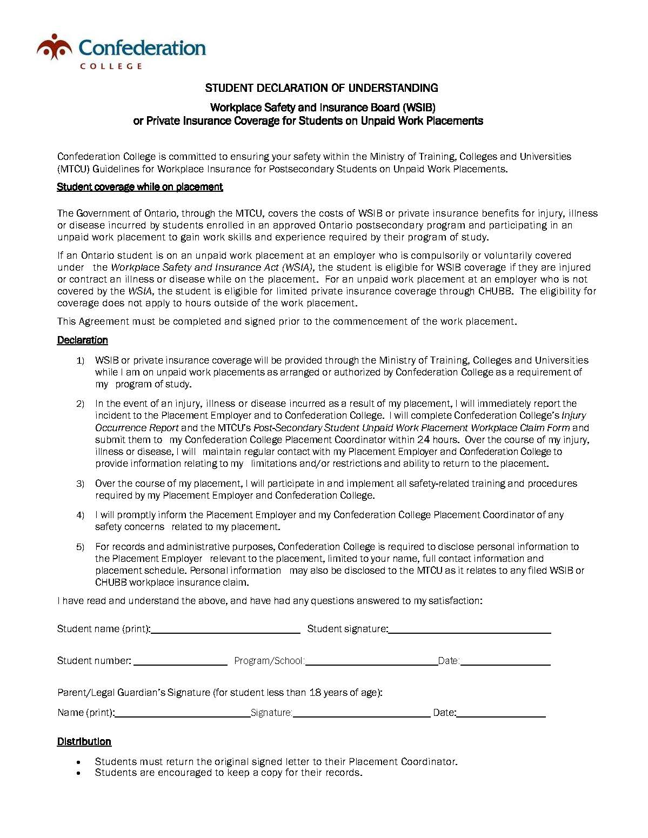
AB xx: APPENDIX 1

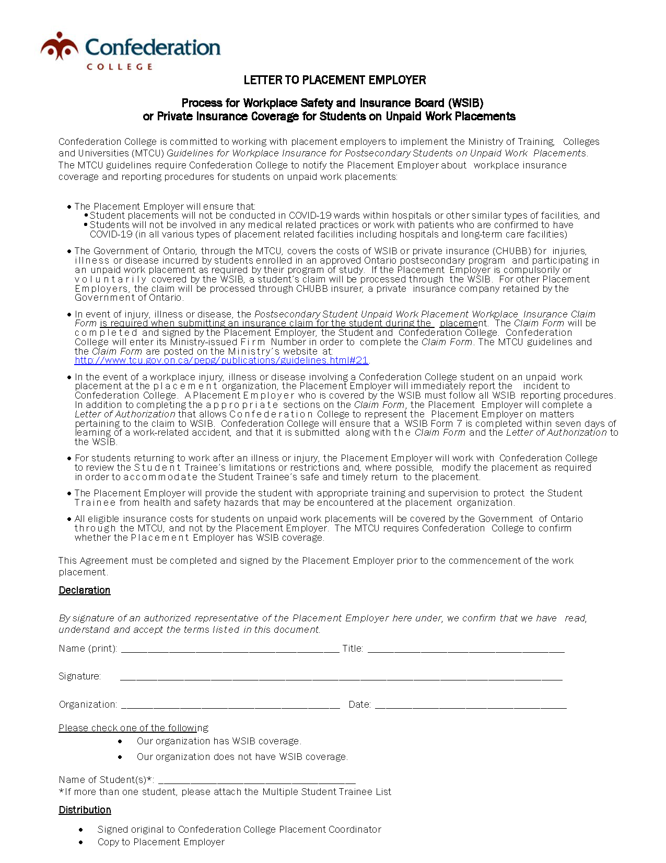
AB xx : APPENDIX 2

AB xx: APPENDIX 3
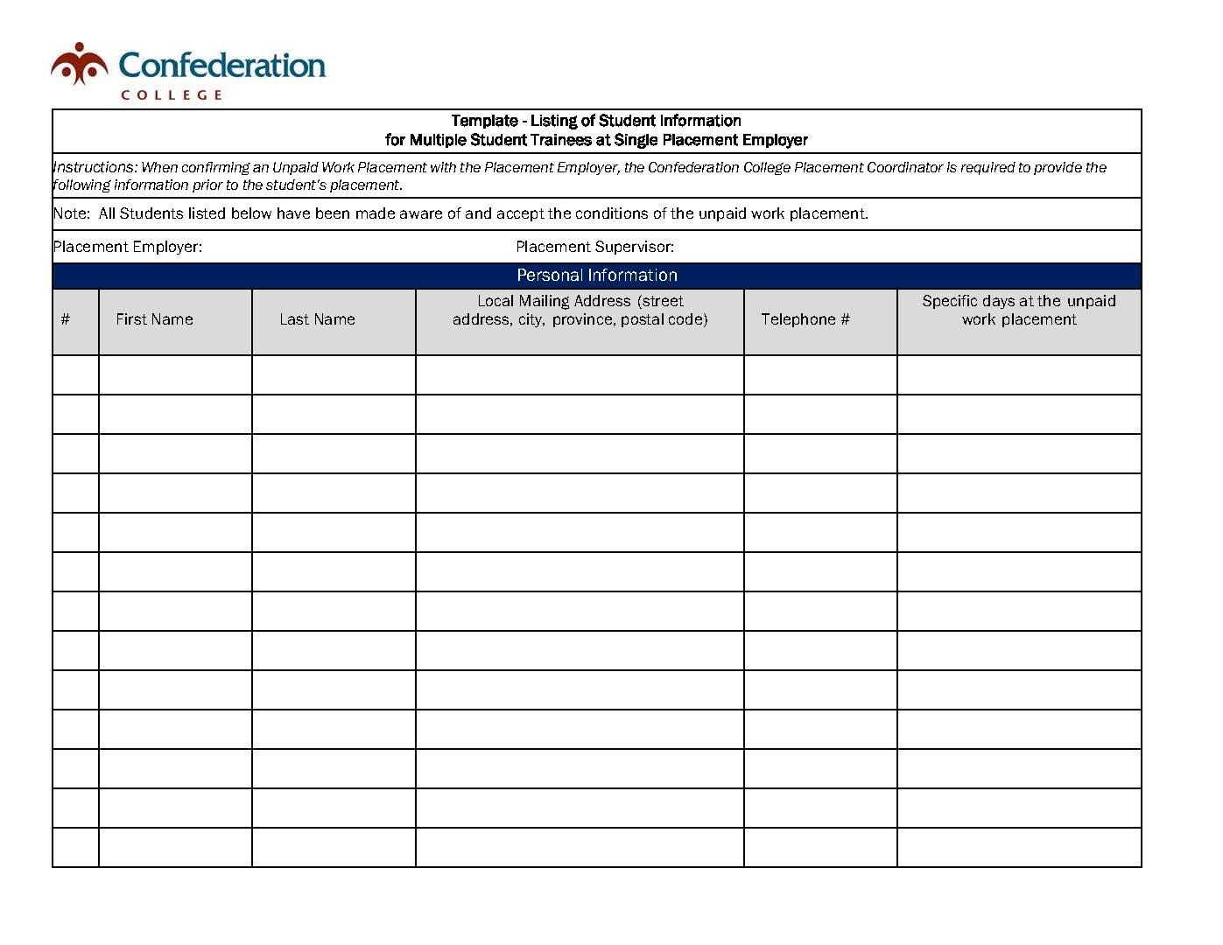

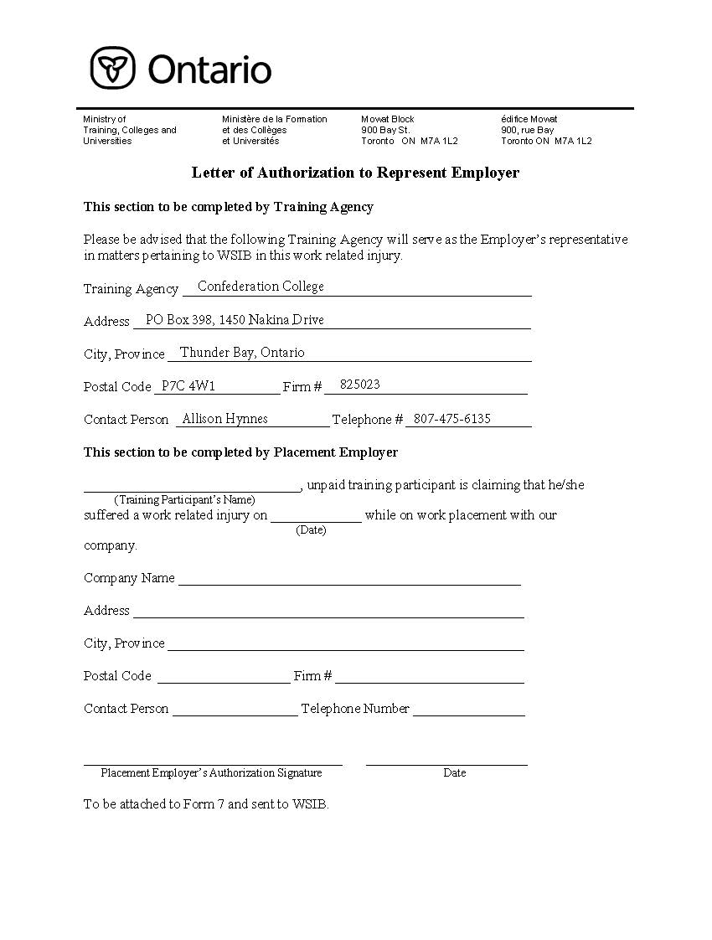
AB xx: APPENDIX 4

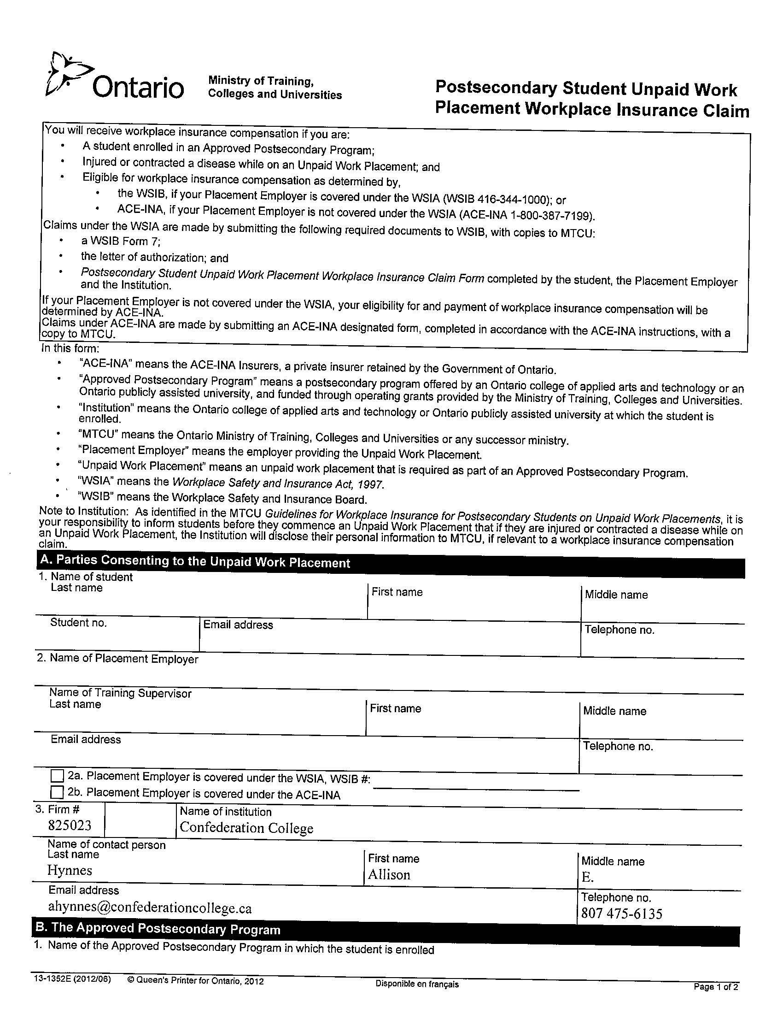
AB xx: APPENDIX 5
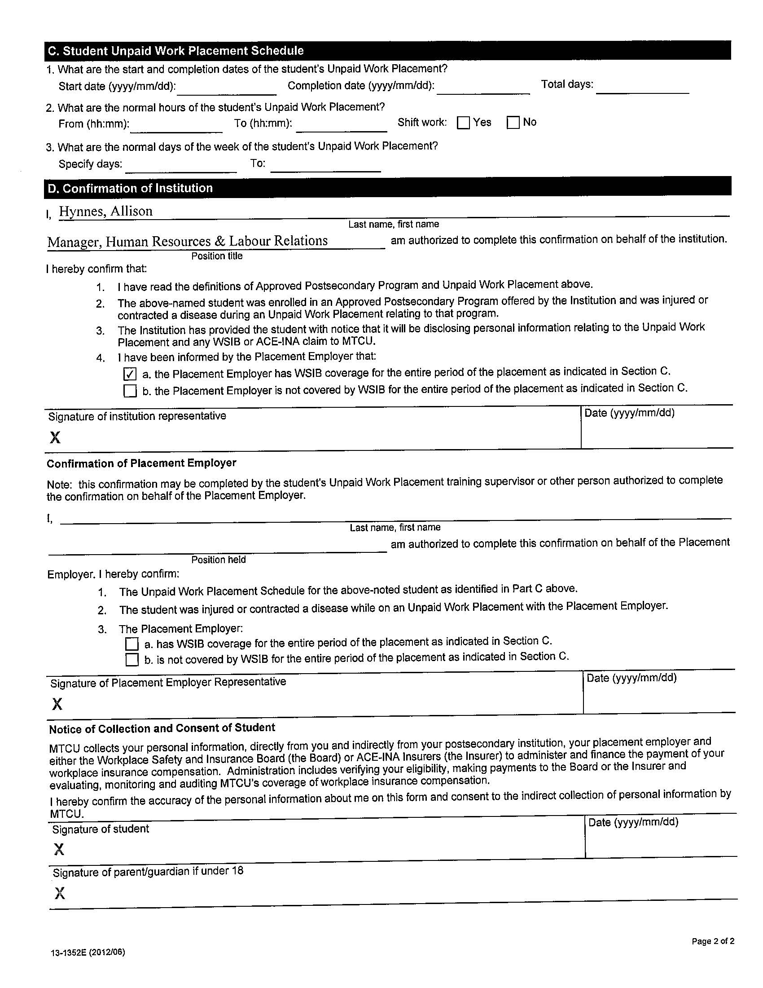

AB xx: APPENDIX 6
