Adding Information to the My Instructor section
Follow these steps to add your information to the My Instructor link in your Blackboard course.
- In the Confederation College Portal, access Blackboard from the Launchpad section.
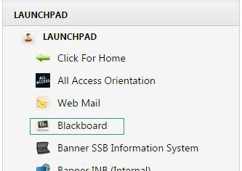
- Once Blackboard has opened, access the course in your course listing that you would like to share your contact information with.
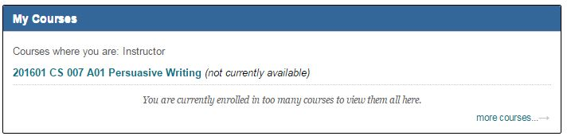
- Within your course, you will see the My Instructor link on the course main menu. Click this link.
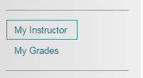

- This will bring you to an empty page. This is the Blackboard Contacts tool. To add your information, click on the Create Contact button.
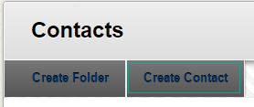
- The following screen will ask for your contact information, including your Title, First Name, Last Name, email address, and any extra information you may want to provide. Note that only the Names and email address are necessary fields.
- Once you have entered all of the desired information, ensure that you check the Make the Profile Available option reads ‘Yes’, and then click the Submit button.
- You will be taken back to the My Instructor page, where your contact has been created.

