Creating a Grade Column
Follow these steps to create a grade column in your Grade Center. This is intended for assignments and class items submitted outside of the Blackboard.
- Log in to Blackboard and open the course within which you’d like to add a graded item.
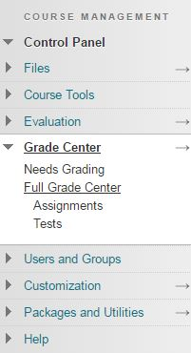
- In your Course Management toolbar, access the Grade Center, and then click the Full Grade Center.
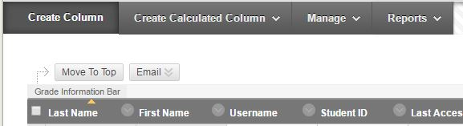
- Your Grade Center will come with two columns; the Weighted Total column and the Total column. These are calculated grades. The Total column sums the number of points of all graded columns in your Grade Center. The Weighted Total will allow you to set certain graded columns as a percentage worth of the student’s final grade. To create a regular grade column, click the Create Column button in the top left of your Grade Center:
- This will bring you to the Create Column interface. Here you will need to give your graded item a Column Name (ie. Assignment 1, Test 1). The only other required field is the Points Possible, which you must set to submit the item. You can always come back and edit these fields later if needed!
- There are many features that you may optionally set on the column, such as a due date, a rubric, and a secondary display parameter. Feel free to utilize any of the options you find useful.
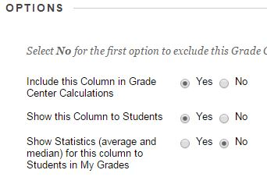
- Ensure that the Include this Column in Grade Center Calculations and Show this Column to Students options are set to Yes. This will allow you to weight the grade in a calculated column, and allow your students to see their grade on this item.
- Now click the Submit button to save your changes.

