Installing Blackboard Collaborate
Follow the steps below to create and link students to a Blackboard Collaborate session.
- Login and access your Blackboard course.
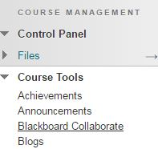
- Under your Course Management toolbar, click on the Course Tools area, and then click the Blackboard Collaborate option.
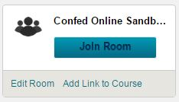
- Click on the Join Room button:
- The following screen will give you some additional details about the session, a join button, and another option to download the Blackboard Collaborate Launcher. Click on this option to download and install the launcher program. You will only need to do this the first time you access Blackboard Collaborate.
- Once the file is downloaded, open the file in your Downloads folder. The installation will look different on Mac and PC systems. Follow the on screen prompts to finish the installation.
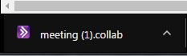
- Once installed, return to your Blackboard Collaborate Join Room page. Click Join Room. This will download a file titled “meeting.collab”.
- Open the file, which will be in your Downloads folder. This will open the Collaborate program, which may take a few moments to load if you have not launched it previously.

