Logging into the Portal
The Confederation College Portal is the gateway to many applications that you will need to use as an Instructor. This area includes links to your employee information, printing and parking, Blackboard, and a wealth of other useful tools. This guide will show you how to access this information.
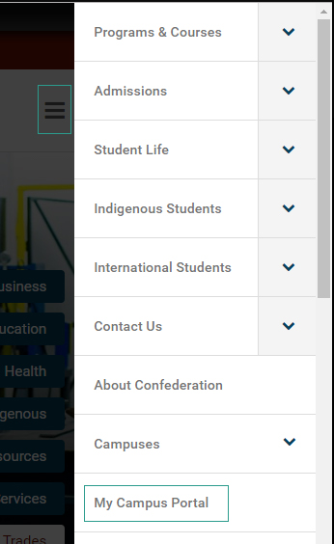
- Navigate to http://www.confederationcollege.ca. At the top of the screen, you will see the My Campus Portal link. If you are on a mobile device, you will need to open the context menu as shown:
Desktop: Mobile:

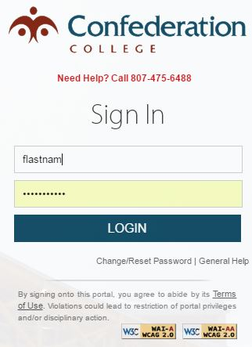
- You will then be presented with a login screen. Here you will need to enter your Username and password. Your username is the first part of your college email address (ie. Flastnam@confederationc.on.ca) and your password. These details can be obtained from the HelpDesk if needed. Click LOGIN to continue.
- Now you will see the Portal content. Here you can launch into any of the College’s software services and see all upcoming events and news items.
