Printing Class Pictures
Follow this guide to access a PDF file of your class list that includes student photos. This will help you learn the names of your students.
- Navigate to http://www.confederationcollege.ca and login to MyCampus Portal. More detailed instructions on logging in are outlined in the Logging into the Confederation College Portal documents in the Faculty Survival Guide.
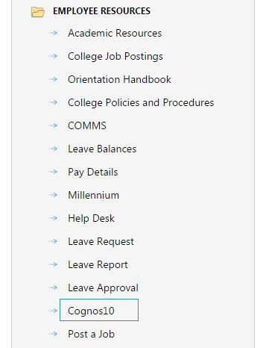
- Within this area you will find a folder titled Employee Resources. Access the tool titled Cognos10.
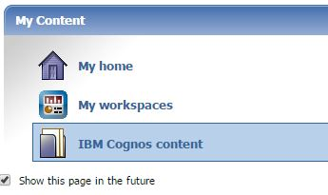
- Access the IBM Cognos Content.
- Now click Faculty Reports, and then Faculty Access. Then, select the current term.
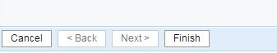
- Now click Finish at the bottom-left of the page.
- This will now compile a list of all of the courses that you are attached to as an Instructor.
- Click on the CRN of the course that you are interested in getting photos from.
- This will show the course details, including the full roster of students, their photos and their email addresses. Clicking the topmost Email and Photos will open your email client with the entire class list populated, and produce a PDF document containing all student names and photos, respectively.
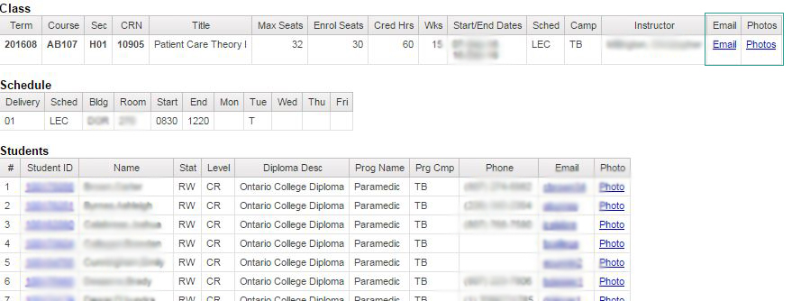
- The PDF will be downloaded to your computer and you can print it at any nearby college printer!

