Weighting your Grade Columns
Follow these steps to use the weighted total column in your Grade Center to calculate the students’ grade according to your course outline.
- Log in to Blackboard and open your Grade center. This tutorial assumes that you have created a number of columns or assignment submission links. If you have not done this, please view the Creating a Grade Column resource first.
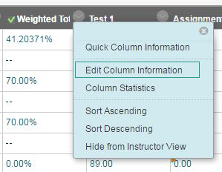
- Within your Grade Center, you will need to find your Weighted Total column, click the drop down menu next to the title of this column, and then select Edit Column Information.
- Within this area you will be able to change any settings. You may want to rename your weighted total column to something more intuitive, such as Final Grade, or Current Grade. Scrolling down you will find a Select Columns area.
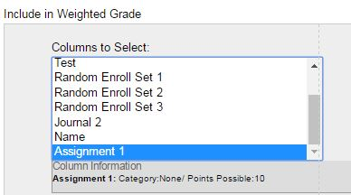
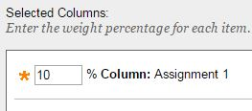
- Within this area, you can select individual columns from the left side of the screen, and move them over into the Selected Columns area by clicking the rightward facing arrow. Then you may assign a percentage worth (ie. This assignment is worth 10% of the final grade).
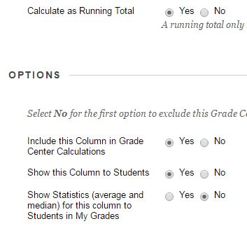
- Ensure that Calculate as a Running Total, Include this Column in Grade Center Calculations, and Show this Column to Students are all set to Yes.
- Finally, ensure that you click Submit to save your changes. If your total weight for all grades in your selected columns area does not add up to 100%, Blackboard will give you a warning. It is okay to submit this and continue, as you can always come back and add more graded items as you create them.
- When you begin entering grades for the items included in the Weighted Total, you will see the overall grade change in this column, this means Blackboard is doing all of the calculations behind the scenes to give the student their grade.

